
Geethanjali College of Engineering and Technology
(UGC Autonomous, Approved by AICTE and Permanently Affiliated to JNTUH)
Department of Computer Science and Engineering
____________________________________________________________

Academic Year 2021-22

Cyber Security Club Members
S.No | Name of the Club Member | Designation & Position
1 | Mrs. Haritha Pujala | Faculty Coordinator
2 | Mrs. Mamatha Botla | Faculty Coordinator
3 | Sai Prakash Chary Vadla | Student Coordinator,Club Founder
4 | Veena Vani Pedduri | Student Coordinator,Club Co-founder
5 | Abhinay Reddy Likki | Student Coordinator, Club Co-founder
6 | T Sree Alekhya | Student Coordinator, Club Co-founder
7 | Duvvuri Sree Sai Soujanya | Student Coordinator,Secretary
8 | Kosgi Aakanksha Reddy | Student Coordinator,Out Reach Lead
9 | Hari Sarada | Student Coordinator,Vice Chair For Strategic planning
10 | Boppidi Nandhini Reddy | Student Coordinator, Out Reach Lead
11 | Sathvika Balijepalli | Student Coordinator, Out Reach Lead
12 | Tanvi Shivani | Student Coordinator,Design Lead
13 | K Rohitha | Student Coordinator,Publicity Lead
14 | Maramamula Sai Sri Vishnu | Student Coordinator, Publicity Lead
15 | Dharavath Rounith | Student Coordinator,Chairman

Cyber Security Club Events
S.No | Name of the event | Organizers ,Resource persons & Held dates
1 | WORKSHOP ON DIGITAL SAFETY | Cyber security club of Gcet,  V.Sai Prakash Chary,gcet  25-2-2022 & 26-2-2022
2 | ETHICAL HACKING AND CYBER SECURITY WORKSHOP | Cyber security club of Gcet,  Santhosh from Supraja Technologies  21-4-2022 TO 23-4-2022

Report
ETHICAL HACKING AND CYBER SECURITY WORKSHOP
DATE: 21-04-2022 to 23-04-2022
FACULTY CORDINATORS:Mamatha ,Haritha
STUDENT CORDINATORS:SaiPrakash Chary V, NandiniTripati , VeenaVani, Pavan Shiva, Sarada, Akanksha, Rounith , Sirisha

CONTEXT:
Ethical hacking and cyber security workshop was conducted by cyber security club of GCET in collaboration with Suprajatechnolgies in Geethanjali college of engineering and technology on the above mentioned dates.

Learning Objective:
In this 3-day Workshop, students will learn about the essential building blocks and basic concepts around cybersecurity such as Confidentiality, Integrity, Availability, Security Architecture, Security Policies, and so on. In addition to these concepts, students were exposed to real time hacking techniques and measures to resolve them. How to protect them-selves from the cyber-attacks, how to respond to them were keenly explained.
And also to learn the industry content students were also offered internships.

About the company:
Supraja technologies is a company solely based on cyber security and it has been successful in giving internships to many students who are currently successfully flourishing in their career. They believe in team commitment and always value creators.

DESCRIPTION

DAY 1:
The day 1 of the workshop was the warm up and introduction session. Students were given introduction and detailing about the workshop process and the process of the internship selection. During the morning session, the speaker gave quite a good reference to the main terminologies included in the cyber security and the main definitions needed for the future reference. Students were also introduced to types of hackers and their role in the field. Phase of ethical hacking were deeply covered. The session became more engaging while the orator asked the students to check on “how secure is their password”, and gave little hints on how google can reveal their data like location and activity without their knowledge.
The lecturer encouraged students to include cyber security as their choice of career and gave students on how to proceed further or make progress in the field. The basic and high-level certifications were introduced to students and explained about their importance.
In the afternoon session, students were engaged with some hands-on spoof mailing activity which made them understand how spam mails or phishing mails are sent by hackers. Many port numbers and the process of 3-way handshake were explained. The speaker also explained about various layers of OSI model and their significance.

Day 2:
On the second day, the orator gave a hint about various response codes and gave detailing about how IP addresses are used. But the main activity on day 2 was “SNIFFING”. The students were given a detailing on what sniffing is and how to tackle the flags in them. The lecturer performed some sniffs and explained about on how to proceed during various levels.
The activity was very engaging as students competed among themselves to crack the hint given and find the flag. All the students actively participated and were successful in finding most of the flags. The students also got to know about the sniffing tool called “Wireshark”. During the sniffing top student’s names were also noted to be evaluated for the internship selection. Over-all the sniffing activity was one of the exciting parts on the session.
During the afternoon session the orator introduced a top called “steganography”. Students were asked to find out the hidden message in images and voice notes using random steganographic tools. Exploring different tools through browsing and trying to find the morse codes hidden in voice notes and this activity was yet another exciting part. Students had found some tools and found out the hidden messages in them. After the hands-on activity the lecturer introduced a website called google dorks. Overall second day students were excited about learning new thing and experiencing them.

Day 3:
The third day was yet another exciting day where the lecturer introduced to website vulnerabilities. Students were given examples of how the vulnerabilities work and different types on vulnerabilities found. Further students were asked to find out more such web applications with vulnerabilities and this activity kept them engaged. Most of the students were successful in finding out various steganographic tools.
During the afternoon session assessment including the basics taught during the whole workshop was conducted to shortlist the students for the internship. From a total of 130 students 53 got selected for the internship.The selected students and all the participants were given participation certificates and certificates of appreciation. The students who got selected were also given their offer letters. Important speeches were delivered by the CEO of supraja technologies Mr. SantoshChaluvadiand the hod of cse department Mrs. SreeLakshmi. Students were enlightened by the career guidance given and the knowledge acquired through the workshop.

Related pictures:

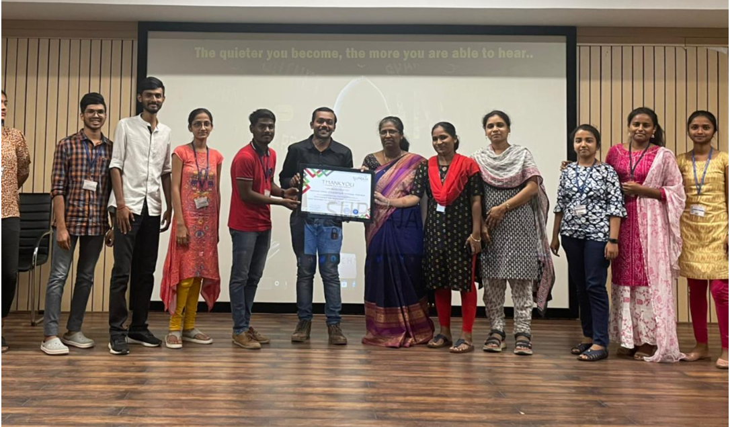

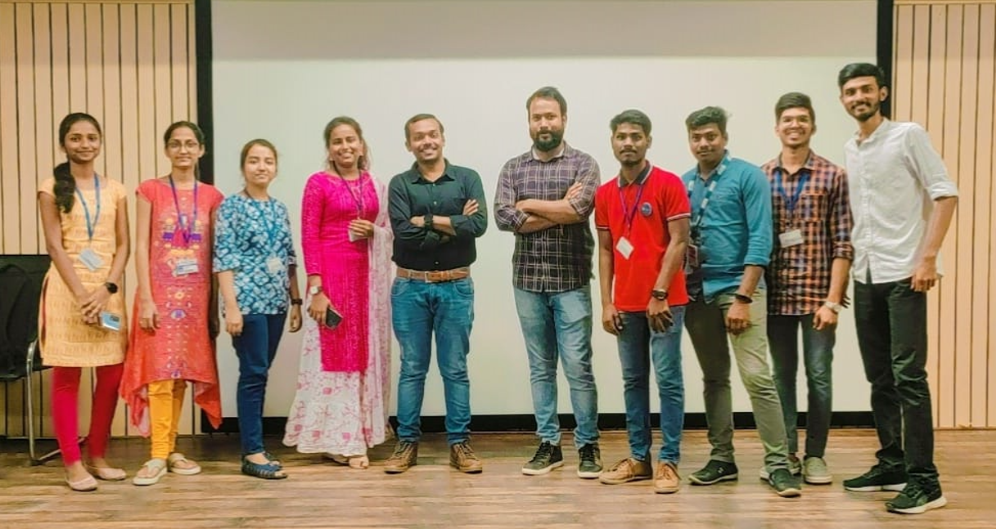
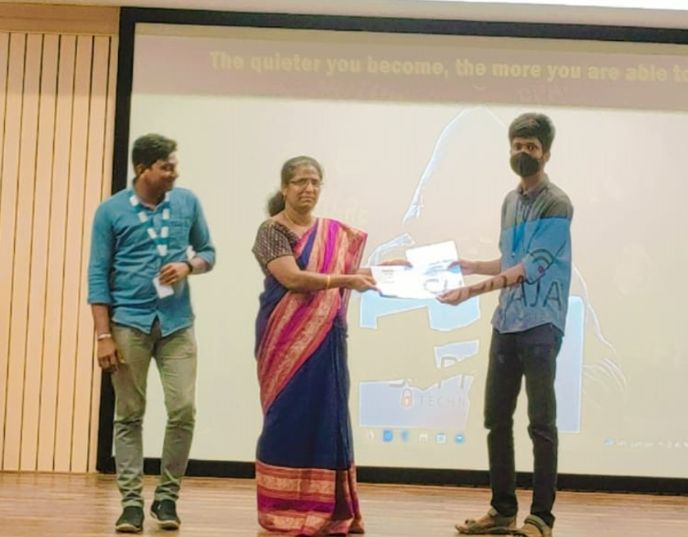
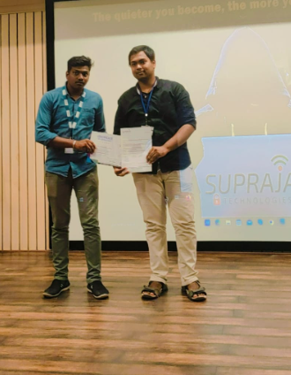
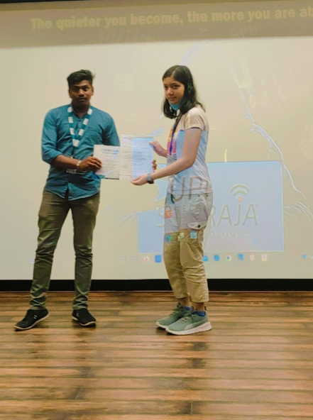

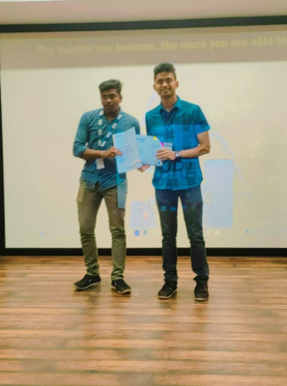

List of students who attended for the workshop:
130 students participated in the workshop.
Saiashrithsarraf | 20R11A05A7
DwarakaAarti | 20R11A0515
B. Karthik | 21R15A0507
TejaVanamala | 19R11A0545
BhoopalamKushal | 19R11A05A0
BHAGYA SREE | 20R11A0570
DanthuriNavyasreeGoud | 21R15A0512
C NUTHAN MAHESH REDDY | 20R11A6216
ChittiSneha | 20R11A6218
SreeyaSankula | 20R11A05B0
GADDAM CHAKRINATH | 20R11A6715
LakshmiShreyaIvaturi | 20R11A0481
T Sanjana | 19R11A0592
Hrishitha. A | 20R11A0584
KOSGI AAKANKSHA REDDY | 20R11A0592
N.SAI NAGA BHARGAVI | 21R15A0510
Devikakadiyala | 20R11A6230
RenukaIlapanda | 20R11A0585
richawakode | 20R11A0544
K Badrinath | 20R11A0484
KhushiJha | 20R11A0593
Shirisha Reddy | 20R11A6239
S.PavanSushanth | 19R11A05D6
CH.Likiesha | 20R11A1210
P.SaiPrerana | 20r11a6240
V ArunValliappan | 19R11A0541
Vishal | 20R11A6204
Faranishath | 19R11A0562
GurramShruthi | 19R11A0566
A K SRI HARSHA | 20R11A0561
NIDHI BODKHE | 20R11A6210
Y. Vishnu vardhanbabu | 20R11A05J0
SaitejaGoudShivalingala | 19R11A0537
A.ANKITH | 20R11A6201
KANITHI HEMANTH | 19R11A05H3
RakshandaThakur | 20R11A6243
K. SyamalaPavani | 20R11A0591
RAMA RAHUL | 20R11A05A3
Rakesh Kumar Bomsetty | 19R11A05J6
ParitoshVatturi | 19R11A0547
BairapakaNithisha | 20R11A6211
MOSALI JYOTHI | 19R11A0425
TANDA RAJESH KUMAR GOUD | 21R15A6206
T. ShailendraSainath | 19R11A0539
Ch. Sravyasri | 19R11A0559
K Chetnagoud | 20R11A0490
P. AmruthaSai Sri | 20R11A0541
G Karthik | 20R11A05K6
Udayasri | 20R11A6257
HarshithVarma | 19R11A05F5
OrugantiRajini | 21R15A0509
P SaiKarthikeya | 20R11A05G4
MandaSowmya | 21R15A0513
T.Rohith Chandra SaiChowdary | 19R11A0445
MounikaPadae | 20R11A6238
HARI SARADA | 20R11A05K9
SathvikaBalijepalli | 20R11A6212
Thotasai Kumar | 20R11A05H5
S Sainithin | 20R11A6250
Sri vardhangoud | 20r11a6227
G Phalguni | 20r11a0576
NutakkiShreya | 20r11a6637
Nandhini | 20R11A6215
D jagadeshwar | 21R15A6205
B.SriNandini | 20R11A6209
MadhiSukrita | 20R11A0596
Revanth K | 19R11A05H1
GudurLikitha | 20R11A0581
V.Bhavana | 20R11A05B7
B. Karthik | 21R15A0507
Ritikaa Kailas | 19R11A0589
S varunreddy | 20r11a6952
SaikethanAdhikam | 20R11A05G8
Gundreddyvaishnavi | 20R11A6226
Damasanisnigdhasri | 20R11A1214
SambariManikanta | 19R11A0535
Jayanth R | 20R11A05A2
RounithDharavath | 20R11A05K2
S. SaiLahari | 20r11a6247
Kanneganti Sri Divya | 20r11a05L3
PriyaSpandanaMendu | 20R11A0599
K Sirisha | 20R11A6229
AlluSaiVineetha | 20R11A6206
Mohammed Shakeel Ahmed | 20R11A6237
K. Saketh Reddy | 20R11A6228
SrirangamVenkata Krishna Naga Sai | 19R11A0538
T SreeAlekhya | 19R11A1248
Akash Reddy Kukkala | 20R11A6233
D. SreeSaiSoujanya | 20R11A0573
Mohammed Ferasat | 20R11A1241
VempatyBhanuVamsi | 20R11A6259
Abhinav Reddy | 20R11A6202
Veenavani | 19r11a0587
B.NutanPavan | 19R11A05E8
Harika | 19r11a1212
Tanvishivani K | 20r11a0523
R MadhavaSai | 19R11A0533
shylicheruku | 20r11a0571
K. UshaNeha | 20R11A0528
MaramamulaSai Sri Vishnu | 20R11A0598
Moses Aashray.K | 20R11A6234
Pulagamvenkatabhanodai | 20R11A0499
C.V.B.RAJU | 21R15A6202
Guna | 19R11A0570
C.Monish | 20R11A05J9
MangalampalliSujan | 20R11A6236
Sathvikparasa | 20r11a6943
PEESARI DILEEP REDDY | 19R11A0530
Pragathi | 20R11A6258
AryaKodte | 20R11A6702
KemidiBharath Kumar | 19R11A0569
Karthik Reddy | 19R11A0560
Ashrith | 20R11A05J4
MogullaAkash Reddy | 19R11A0576
ORAGANTI ROHITH GOUD | 20R15A0504
J Manish | 20R11A0482
ShaikAasim | 19R11A0536
P JyothiLatha | 20R11A0469
AkhilGoud | 20r11a05f9
AqsaZareen | 19R11A0550
HaripriyaGurla | 20R11A05L0
Likki.Abhinay Reddy | 19R11A05B6
G.v.Mythili | 20R11A0517
ChintalaAbhishek | 19r11a0556
K.LaxmiSwaroopa | 20r11a0529
NandiniTripathi | 19R11A0580
Sriman | 19r11a1232

List of students who got selected for the internship:
Total of 53 students got selected for internship.
P.veenavani | 19r11a0587
P Saikarthikeya | 20R11A05G4
MadhiSukrita | 20R11A0596
Rama Rahul | 20R11A05A3
RichaWakode | 20R11A0544
HaripriyaGurla | 20R11A05L0
Devikachowdary | 20R11A6230
KhushiJha | 20R11A0593
K. Madhusri | 20r11a1231
J MANISH | 20R11A0482
P.SaiPrerana | 20r11a6240
TanviShivani K | 20R11A0523
SambariManikanta | 19R11A0535
R MadhavaSai | 19R11A0533
GADDAM CHAKRINATH | 20R11A6715
B SRINIDHI | 20R11A6210
AdepuVishal | 20R11A6204
AryaKodte | 20R11A6702
MenduPriyaSpandana | 20R11A0599
DwarakaAarti | 20R11A0515
Sri vardhangoud | 20R11A6227
Mohammed Ferasat | 20R11A1241
Aryan Kodte | 20R11A6703
TANDA RAJESH KUMAR GOUD | 21R15A6206
SathvikParasa | 20r11a6943
Gundreddyvaishnavi | 20R11A6226
K.MosesAashray | 20R11A6234
T SreeAlekhya | 19R11A1248
A K SRI HARSHA | 20R11A0561
S.PavanSushanth | 19R11A05D6
MaramamulaSai Sri Vishnu | 20R11A0598
K Rohitha | 20R11A0588
LakshmiShreyaIvaturi | 20R11A0481
KOSGI AAKANKSHA REDDY | 20R11A0592
KemidiBharath Kumar | 19R11A0569
V.BhanuVamsi | 20R11A6259
KanamarlapudiRevanth | 19R11A05H1
Jayanth R | 20R11A05A2
ParitoshVatturi | 19R11A0547
S varunreddy | 20r11a6952
AnanyaChepuri | 20R11A0469
T.Rohith Chandra SaiChowdary | 19R11A0445
D Karthik Reddy | 19R11A0560
D jagadeshwar | 21R15A6205
AshrithGadeela | 20R11A05J4
S SaiNithin | 20R11A6250

Feedbacks received from students:
- The quieter you become, the more you are able to hear.. -Ram Dass
Learning new things improves your knowledge base,Learning things which make you productive boosts your confidence!!
The 3 Days Workshop on Ethical Hacking and Cybersecuritywas amazing the facilitators were friendly who answered my queries. Which upgraded my practice approaches on Cyber-security.
I am looking forward to work, learn and enjoy with team SUPRAJA Technologies.
--R MadhavaSai
- I found the workshop to be very informative. The workshop provided you with specific hands-on skills. The skills will be invaluable in my professional and personal life. It is encouraging to know that these are techniques that can be used that are understandable and that you can use on a daily basis.
--Bharathkumar

- This workshop has been a wonderful experience. I feel I have gained a skill which I will consistently use throughout my life with friends, and of course myself. The information you have given us has been clear and concise, and you created a safe and effective learning environment.
--Karthik

- I've been interested in cybersecurity from the day I passed my 10th standard, but couldn't do anything due to the lack of mentoring and path to follow. This workshop totally enlightened me and gave me a few insights and set a path to achieve in future. All aside, I enjoyed and learned a lot in a comfortable environment. The style and the knowledge of the presenter Santosh bro and his team.
Eagerly waiting for the internship to onboard and kickstart my journey. I would like to thank the organising team for a connecting us with supraja technologies
I found the course very productive... discussing the various aspects of incident response. I fully understood the content and look forward to putting some of the stuff into practice.
--Manikanta

- Attending the 3-day Cyber Security workshop hosted by Supraja Technologies was one of the best decisions I have taken this year. It wasn't like any other workshop where they go on and on with the theory, the students were explained the concepts and then were assigned tasks related to those. The challenges were intriguing and competitive. This approach let us embed the topics in our minds.
The highlight of the Bootcamp was the extremely friendly teachers, it almost felt like a brotherhood. Even though I was keen on Cysec as a technology, I have never dedicated any time to it. The Bootcamp had a positive impact on the same, and from now I will do my best to refine my skills.
Thank you Supraja Technologies, for providing us with this prominent opportunity.
--Paritosh

A Report on
Digital safety workshop

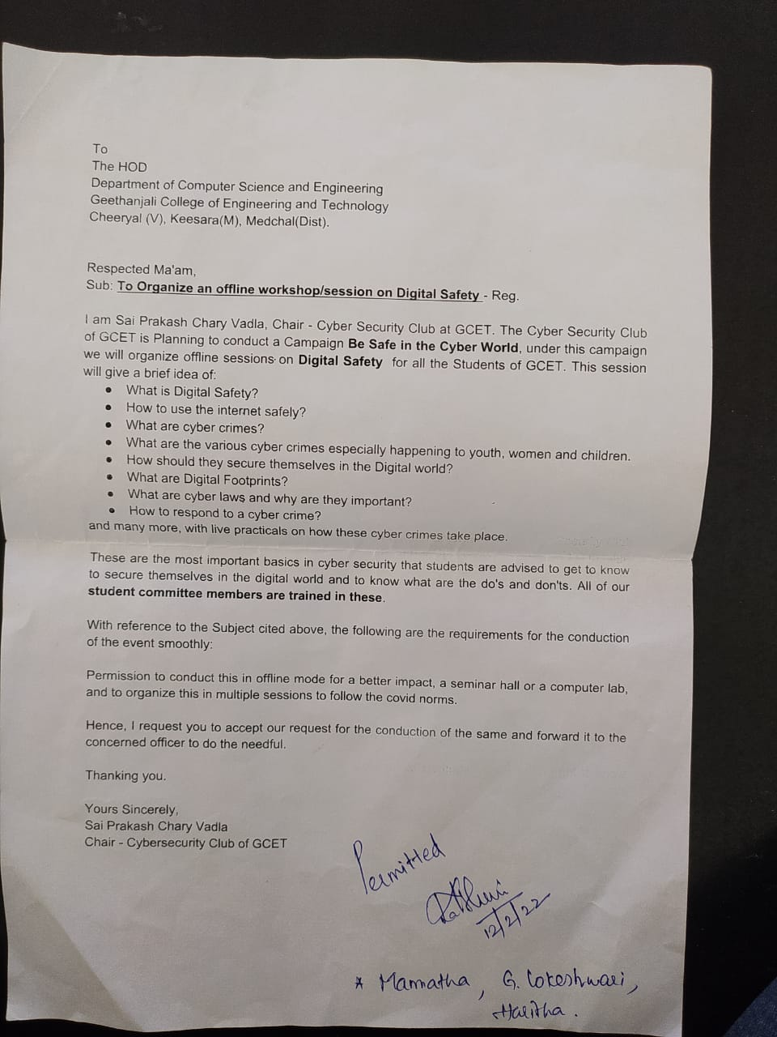

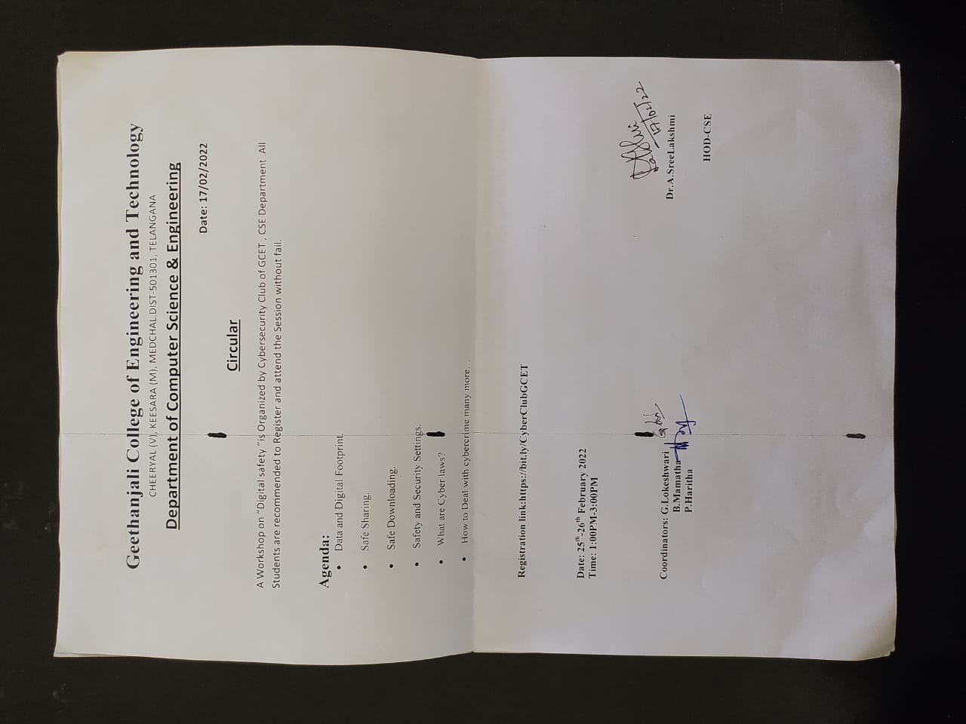

DATE: 25-02-22 and 26-02-22
STUDENT COORDINATORS:
3rd year:
SaiPrakash Chary V, NandiniTripati, VeenaVani, Pavan Shiva
2nd year:
Sarada, Akanksha, Rounith, Sirisha,
OBJECTIVE: The workshop’s main agenda was to develop awareness on digital safety to the students who mostly be active on the digital platforms.
OUTCOME: Students have gained sufficient knowledge on how to prevent and limit the hazards that come with integrating digital technologies, platforms, and services by practicing Online Safety.

DESCRIPTION:
We have designed the seminar in such a way that they get to know what is happening to their data on internet and how can they prevent the hackers from hacking their data.
Our club tried to focus on many critical terms that are important to be known, such as digital footprints, dark web, key logging and tab nabbing. The students were very not clearly aware of the topics as such and were very enthusiastic to learn about them.
On the day 1 we have conducted the workshop with second year students and on the second day we have conducted the workshop with third year students. The response from both the sessions was amazing. They also got to know how to secure their data manually and how can a hacker steal data due to their simple negligence.
Overall, the feedback for the workshop from both students and supporting faculty was overwhelming. We shall plan for similar workshops and seminars in near future.
RELATED PICTURES:
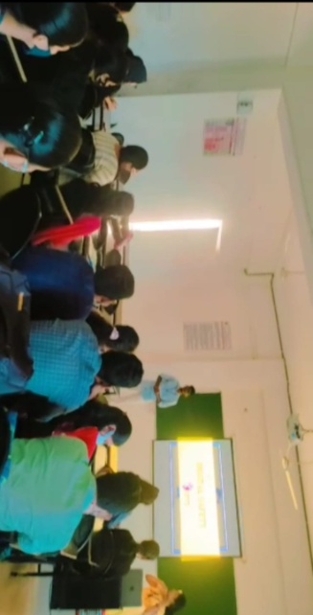
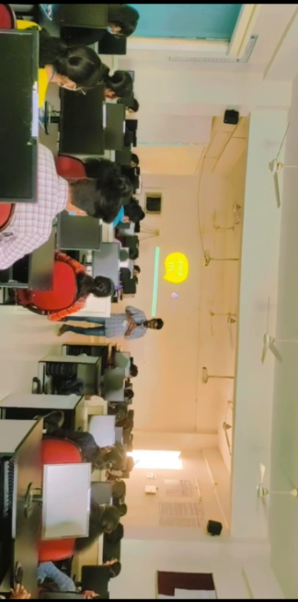
List of students who attended for the workshop:

Name of the student | Year |  | Roll Number
S.Yuktha | II |  | 20R11A0523
Saiashrithsarraf | II |  | 20R11A05G7
Anisha | II |  | 20R11A05A7
Devikakadiyala | II |  | 20r11a05d5
Teak Shreya | II |  | 20R11A6230
BoppidiNandhini | II |  | 20R11A05H3
V.Lahari | II |  | 20R11A6215
Sri Vaishnavi | II |  | 20R11A05P9
K. Ushaneha | II |  | 20R11A05K7
Pragathi | II |  | 20R11A0528
B.Suma Reddy | II |  | 20R11A6258
P. AmruthaSai Sri | II |  | 20r11a05j5
Hanifa | II |  | 20R11A0541
SathvikaBalijepalli | II |  | 20r11a05k8
RaminiPoojitha | II |  | 20R11A6212
D.sreesaisoujanya | II |  | 20R11A05G5
M.Sai Sri Vishnu | II |  | 20r11a0573
Renesh Krishna | II |  | 20R11A0598
Khushi | II |  | 20r11a0543
E.HiranmayaSharvani | II |  | 20R11A05J7
B.Sreshta | II |  | 20R11A05K3
Pabbashreya | II |  | 20R11A05J8
AnushaKasturi | II |  | 20R11A05F7
C. Rajendra Prasad | II |  | 20R11A05E6
Omprakash | II |  | 21R15A6602
KotiPranav | II |  | 20r11a05f6
Jayanth R | II |  | 20R11A6652
B SWABHAN RAO | II |  | 20R11A05A2
Manasa | II |  | 20R11A0567
Himabindu. Ramatenki | II |  | 20R11A05H8
RayapudiNagausha | II |  | 21R15A0517
G.V.MYTHILI | II |  | 20R11A6244
V. Nikitha | II |  | 20R11A0517
THOGARU SAI KARTHIK | II |  | 21R15A0518
Y. Vishnu | II |  | 20R11A05H4
Bhanusri | II |  | 20r11a05j0
PoorviJatoth | II |  | 20r11a05l2
V.Lahari | II |  | 20R11A05N4
KhushiJha | II |  | 21r15a0523
GaddamChakrinath | II |  | 20R11A0593
S Jyothi | II |  | 20R11A6715
Tolith Manish | II |  | 20R11A05A6
Harikrishna | II |  | 20r11a6756
Aryan Kodte | II |  | 20r11a6740
N. Udaykumar | II |  | 20R11A6703
Sreethanvala | II |  | 20R11A05M6
Gopichand | II |  | 20r11a6752
DeekshithaPagadala | II |  | 20r11a6754
Deepika | II |  | 20R11A05N1
V Vardhan Reddy | II |  | 20r11a05l9
Shaguftha | II |  | 20R11A6758
Mohammad Abdul Khaliq | II |  | 20R11A05G9
Saisrujan | II |  | 21r15a6705
SundarSrinivas | II |  | 20r11a6732
AnkamSaahithi | II |  | 20R11A05P3
Nithish Reddy | II |  | 20R11A05J3
VarikoluMadhavan | II |  | 20R11A05M3
Namitha Joanne | II |  | 20r11a05p4
SINGAM SAI KIRAN | II |  | 20r11a05m7
Sruthisingh | II |  | 20R11A05P0
BamandlaNikhileshwar | II |  | 20R11A05P1
M Vansh | II |  | 20R11A05J6
Karthik | II |  | 20R11A05L7
Ushaswisamayam | II |  | 20R11A05K6
DhritiSheerla | II |  | 20r11a05h6
Ayesha sultana | II |  | 20R11A0547
Ananya | II |  | 20r11a6704
Ch.MahithaRao | II |  | 20r11a6725
Ch.HencyChowdary | II |  | 20r11a6709
Ramyasree | II |  | 20R11A6710
VA Tanmai | II |  | 20R11A6707
pokala. nithyasai | II |  | 20R11A6759
AbidHussain | II |  | 20r11a6743
Hemamanognakollipara | II |  | 20R11A6730
M.SHRUTHI | II |  | 20r11a6720
E V RevanthKarthik | II |  | 20R11A6728
RichaWakode | II |  | 20R11A6714
Bari Sharath Kumar | II |  | 20R11A0544
KorubilliLaxmiSwaroopa | II |  | 20R11A0568
Karunya | II |  | 20r11a0529
Satyasravanisamayam | III |  | 19R11A05M4
JahnaviPeddineni | III |  | 19r11a05p4
L.Abhinay Reddy | III |  | 19r11a05d0
D.RajyaLakshmi Devi | III |  | 19R11A05B6
N.LasyaPriya | III |  | 19R11A05L4
R.Bhargavi | III |  | 19R11A0579
T Sanjana | III |  | 19R11A05P0
Indhumathi | III |  | 19R11A0592
Sahithi Sri cheruku | III |  | 19R11A05P3
G.Shruthi | III |  | 19R11A05L2
Mani | III |  | 19R11A0566
Faranishath | III |  | 19r11a0535
V Mahesh Chandra | III |  | 19R11A0562
V . Jeeshitha | III |  | 20R15A0506
Sri Priya | III |  | 19R11A0542
K Harshita | III |  | 19R11A0596
Kunche Ravi Kumar | III |  | 19R11A05B3
SaiAniketh | III |  | 19R11A0520
Jayadhwaj Reddy | III |  | 19r11a0528
Balanikhil | III |  | 19R11A05M2
G.Bhargavi | III |  | 19R11A05N7
V vinitha | III |  | 19R11A0514
Nikhila | III |  | 19R11A0544
VarshithaSampath | III |  | 16r11a05m5
Samyuktha Alfred | III |  | 19R11A05P1
VudhanthiNeeraja | III |  | 19R11A05D4
S.PavanSushanth | III |  | 19R11A0548
ShaikMehanazZaman | III |  | 19R11A05D6
N shreya | III |  | 19R11A05P5
PanyamBadrinath Reddy | III |  | 19R11A0527
E. AKHILA | III |  | 19R11A05C9
AqsaZareen | III |  | 19R11A0508
T. LakshmiPrasanna | III |  | 19R11A0550
N.J.Sanjana | III |  | 19R11A05E0
Inalajahnavi | III |  | 19R11A05N5
BATTU SAIRAM | III |  | 19R11A05M0
A. PreethiPavani | III |  | 20R15A0522
Prajna | III |  | 19R11A05K4
MUTHYALA VIVEK | III |  | 19R11A05D2
Sreemant | III |  | 19R11A05N3
Vikasyadav | III |  | 19R11A0512
Hemanthreddy | III |  | 19R11A05L6
T. ShailendraSainath | III |  | 19r11a05b2
Mehakar Mahesh | III |  | 19R11A0539
K. Nova | III |  | 19R11A0526
Adit S Kumar | III |  | 19R11A0517
PEESARI DILEEP REDDY | III |  | 19R11A0501
DevulapalliSree Naga Bhavya | III |  | 19R11A0530
ShaikAasim | III |  | 19r11a0507
Siddamroja | III |  | 19R11A0536
ORAGANTI ROHITH GOUD | III |  | 19R11A05P7
KemidiBharath Kumar | III |  | 20R15A0504
Sriya | III |  | 19r11a0569
MapatiBhanu Sri | III |  | 19R11A0519
K.SowmyaSree | III |  | 19R11A0524
D himasamiirr | III |  | 19R11A0518
ArunValliappanValliappan | III |  | 19r11a0505
Saketh | III |  | 19R11A0541
G.Dinesh | III |  | 19R11A0540
M.Ravinder | III |  | 19R11A0511
AMRAJ RAJESH KUMAR | III |  | 19R11A0523
Venkatakrishna Naga saiSrirangam | III |  | 20R15A0502
Mamidi. Likhitha | III |  | 19R11A0538
Tanvi | III |  | 19R11A0522

Academic Year 2022-23

Cyber Security Club Members

S.No | Name of the Club Member | Designation & Position
1 | Mrs. Haritha Pujala | Faculty Coordinator
2 | Mrs. Mamatha Botla | Faculty Coordinator
3 | Sai Prakash Chary Vadla | Student Coordinator,Club Founder
4 | Veena Vani Pedduri | Student Coordinator,Club Co-founder
5 | Abhinay Reddy Likki | Student Coordinator, Club Co-founder
6 | T Sree Alekhya | Student Coordinator, Club Co-founder
7 | Duvvuri Sree Sai Soujanya | Student Coordinator,Secretary
8 | Kosgi Aakanksha Reddy | Student Coordinator,Out Reach Lead
9 | Hari Sarada | Student Coordinator,Vice Chair For Strategic planning
10 | Boppidi Nandhini Reddy | Student Coordinator, Out Reach Lead
11 | Sathvika Balijepalli | Student Coordinator, Out Reach Lead
12 | Tanvi Shivani | Student Coordinator,Design Lead
13 | K Rohitha | Student Coordinator,Publicity Lead
14 | Maramamula Sai Sri Vishnu | Student Coordinator, Publicity Lead
15 | Dharavath Rounith | Student Coordinator,Chairman

Cyber Security Club Activities
S.No | Name of the event | Organizers ,Resource persons & Held dates
1 | CYBER CONGRESS 2022 | Cyber security club of Gcet  - Mr. Anil Rachamalla, Founder End Now Foundation (Internet Ethics and Digital Wellbeing Expert)  - Sri. S.Harinath, Asst. Commissioner of Police (Cyber Crimes - Rachakonda Commisionerate)  - Sri. Sai Teja Kaveti Co-founder End Now Foundation (Internet Ethics and Digital Wellbeing Expert)  - Mr. Rakesh Dubbudu, Founder Factly (Fact Checking Expert)  - Sai Krishna (Cyber Security Consultant at Cybersecurity CoE Telangana)  - Ms. Sravani Asuri, Founder DiginomaD  - Dr Boyanapally Philip Kumar, Care Hospital (Psychiatrist)  21-10-2022 & 22-10-2022
2 | (3-day bootcamp)+Hackathon on Ethical Hacking and CyberSecurity Fundamentals. | Cyber security club of Gcet,  Supraja Technologies Team  23-3-2023 to 26-3-2023

CYBER CONGRESS 2022


Geethanjali College of Engineering and Technology
Cheeryal (V), Keesara (M), R.R.Dist.-501 301

REPORT

EVENT DETAILS:
- Date : 21st October 2022, 22nd October 2022
- Venue : Geethanjali College of Engineering and technology.
- Number of participants : 127

FACULTY CORDINATORS:
- Mrs. Mamatha Botla
- Mrs. Haritha Pujala

STUDENT CORDINATORS:
- Sai Prakash Chary Vadla
- Veena Vani Pedduri
- Abhinay Reddy Likki
- T Sree Alekhya
- Duvvuri Sree Sai Soujanya
- Kosgi Aakanksha Reddy
- Hari Sarada
- Boppidi Nandhini Reddy
- Sathvika Balijepalli
- Tanvi Shivani
- K Rohitha
- Maramamula Sai Sri Vishnu
- Dharavath Rounith

EVENT DESCRIPTION:

Cyber Congress is the annual flagship event of Cyber Security club of Geethanjali College of Engineering and Technology. Cyber Congress 2022 aims at promoting and spreading Cyber awareness in association with End Now Foundation. It aspires to introduce the fundamentals of Cybersecurity and promote awareness on the occasion of Cyber Awareness month. The event was successfully held comprising various guest lectures and fun activities which were both informative and encouraging for students. All the lectures were primarily based on cyber awareness and promoting students to be internet conscious.

SCHEDULE:

DAY 1

Sno | TIME | EVENT | DELIVERED BY
1 | 10:00 AM - 11:00 AM | Inauguration / Keynote Session | - Sri. S.Harinath,  Asst. Commissioner of Police (Cyber Crimes - Rachakonda Commisionerate)  - Sri. Sai Teja Kaveti Co-founder End Now  Foundation (Internet Ethics and Digital Wellbeing Expert)
2 | 11:00 AM - 11:45 AM | Fake News | Mr. Rakesh Dubbudu, Founder Factly (Fact Checking Expert)
3 | 12:00 PM - 12:45 PM | ( Student Session )
4 | 1:00 PM - 2:00 PM | Lunch
5 | 2:00 PM - 2:15 PM | Fun Activity
6 | 2:15 PM - 3:00 PM | Cyber Security as a career | Sai Krishna  (Cyber Security Consultant at Cybersecurity CoE Telangana)
7 | 3:15 PM - 4:00 PM | Empowerment via Social Media | Ms. Sravani Asuri, Founder DiginomaD
8 | 4:15 PM - 5:00 PM | Music Band

DAY 2

Sno | TIME | EVENT | DELIVERED BY
 | 9:20 AM -10:00 AM | Student Interaction
1 | 10:00 AM - 11:00 AM | Internet Addiction | Dr Boyanapally Philip Kumar, Care Hospital (Psychiatrist)
2 | 11:00 AM - 12:00 AM | Why Consent is Different Online and Offline? | Mr. Anil Rachamalla, Founder End Now Foundation (Internet Ethics and Digital Wellbeing Expert)
3 | 12:00 PM - 12:45 PM | Picture Interpretation / Thematic Painting | End Now Foundation
3 | 1:00 PM - 2:00 PM | Lunch
4 | 2:00 PM - 2:15 PM | Fun Activity
5 | 2:15:00 PM - 3:00 PM | Social Engineering Crimes and Digital Intelligence | Mr. Anil Rachamalla, Founder End Now Foundation (Internet Ethics and Digital Wellbeing Expert)
6 | 3:00 - 4:00 | Prize Distribution and Valedictory

DAY-1 – 21st October 2022
The day-1 or the formal inaugural day of the Cyber Congress 2022 was held among the dignitaries like Mr. S. Harinath garu, Assistant Commissioner of police Rachakonda Commissionerate and Mr. Sai Teja Kaveti garu, Co-founder of End Now Foundation. The event was inaugurated in the presence of Mr. Ravinder Reddy garu, Chairman and Dr. Udaya Kumar Susarla garu, Principal and Mrs. Sree Lakshmi garu, HOD CSE department and our faculty.

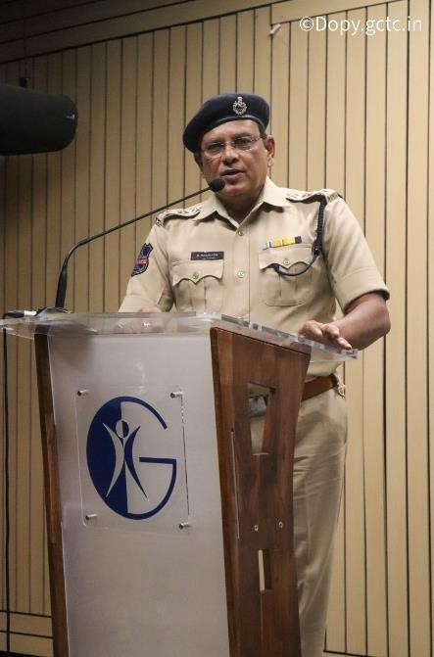
Session 1:

Mr. Harinath garu, the Chief Guest of the event was also the Key Note speaker of the day. As, the commissioner of cyber-crimes, sir has dealt with many real-time cyber fraud cases. He had educated students on various types of cyber-crimes happening and how the scope of cyber- crimes is increasing day-by-day. His speech included on how the cyber police of Hyderabad were able to find many cyber fraudsters and help the innocent, through which sir conveyed on how to be more careful while using any internet application. Many crimes that were mainly focusing students like money and job frauds were also covered through the session mainly alerting them how to be conscious through the frauds. Sir gave information on how to deal with frauds and the process of complaining about it. Overall, the speech enlightened students on the present-day cyber-crime happenings and made them conscious about them.

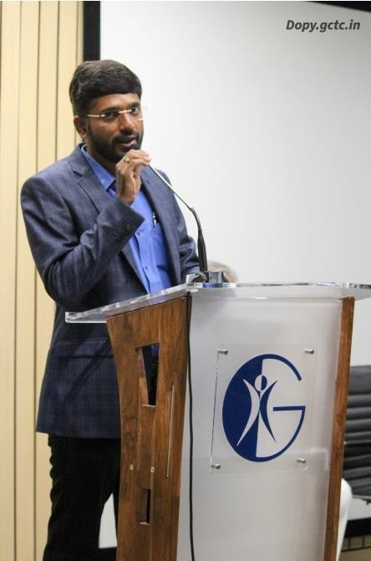
Session 2:

Mr. Sai Teja Kaveti garu is the Co-founder of End Now Foundation and also the Guest of Honor for the event. Sir has given a welcome speech on inaugural ceremony on his experience in the field. He has explained on how students are addicted to internet and social media world. He orated on how internet addiction is harmful and he also suggested few ways to reduce the time on internet. Involving oneself in works other than social media will also improve their mental health along with physical health. His speech summarized about digital well-being which is also the moto of the End Now Foundation. Sai Teja sir helps people on internet to improve their experience on internet by promoting digital well-being. Finally, he also guided students on career in digital well- being and motivated them.

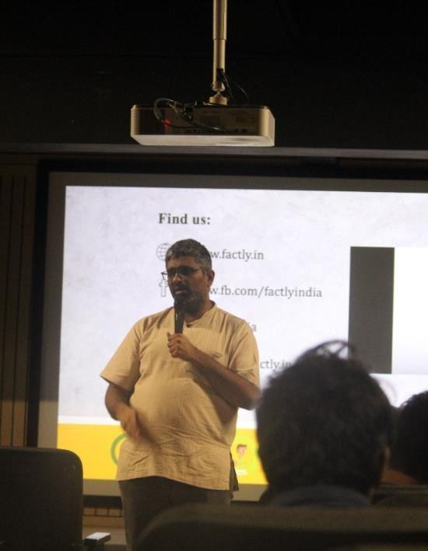
Session 3:

Mr. Rakesh Dubbudu, the Founder of Factly was the next speaker of the day on the key topic ‘Fake news’. Rakesh sir has started the seminar with a live example on how fake news are spread by creating a fake news on the students with their picture. He explained how easy it is to create a fake news from anywhere and also how hard it is to stop it from spreading. Leading the students, he involved various real- time fake news that were widely spread and were the reason for violence. Sir had given us an overview on why a fake news is created and how it can be possibly stopped. The main element of Rakesh sir’s speech was the fact checking websites that he introduced. Various tools that can help people find the truth behind any news that is spreading. He concluded by telling on how important it is to be responsible on any news that we are sharing.

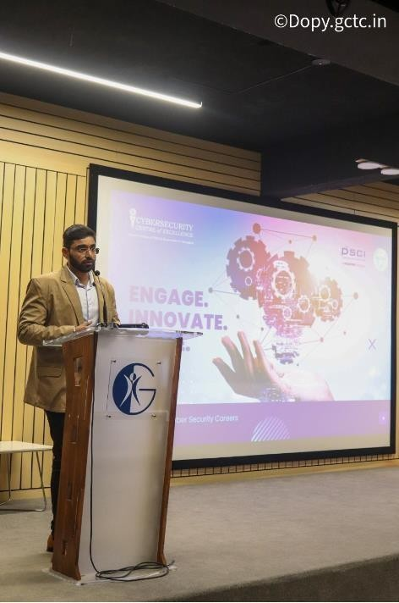
Session 4:

Sai Krishna Singupuram garu is a Technical Consultant at Cyber Security Center of Excellence, DSCI. Sai Krishna garu has given a lecture on keen and informative topic that is ‘Career in Cyber Security’. Most of the students who attended the event were very excited about the topic and keeping up the expectations, sir has started off by giving advice on skill improvement. He included various skills that will help students excel in the field. He then suggested different certifications that can add-up value to their resume. Sir has given a blue print on how to get started for various roles under cyber security. He made it engaging by sharing his journey in the field and on how he managed to reach the position that he holds. Overall, students received plenty of knowledge on how to pave their cyber- security career.

Session 5:

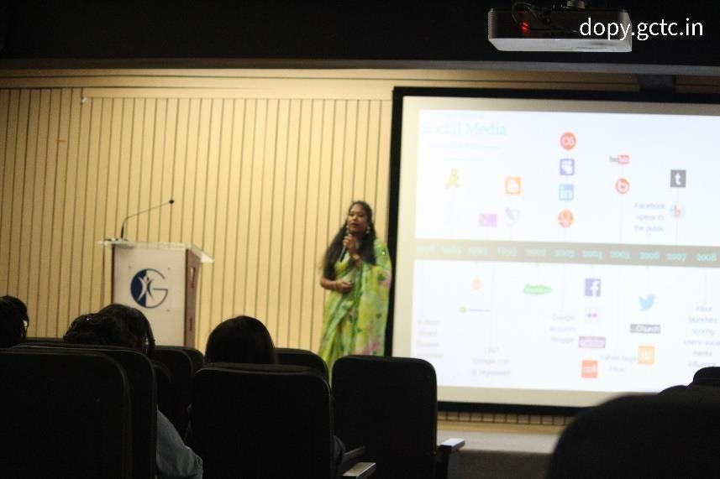
Mrs. Sravani Asuri, the Founder of DiginomaD, was the final speaker of the day. Mam brought in plenty positive energy to the crowd and made her seminar very interactive. ‘Empowerment via Social Media’ was the topic of the seminar and mam has made it very interesting by including all case studies that were popularly known and grabbed students’ attention. She started off by explaining how social media is not all bad. Taking the example of popular
social media stars who create content on social media to build their careers. Sravani mam winded up by giving insights on how can social media be used for the betterment.

Summary:
The day-1 was filled with guest lectures that gave all students overwhelming experience from all the speakers and the guidance given by them was very motivating. Summing up the day-1 we have a musical event by a private band to maintain the enthusiasm and gear up for day-2.

DAY-2 – 22nd October, 2022
The Cyber Congress 2022 had a main motto of providing students with overall experience of the interesting and engaging event. With the same enthusiasm we started the Day-2 of cyber congress with much more interesting topics to focus on.

Session 1:
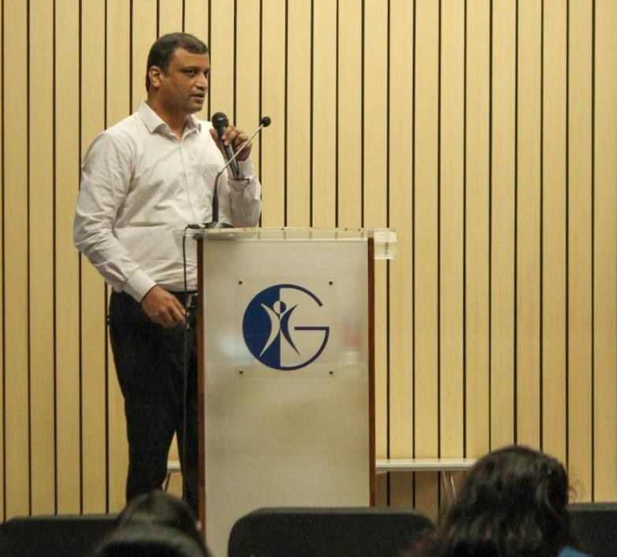
Dr. Boyanapally Philip Kumar garu, Consultant Psychiatrist, Care hospital was the first speaker of the day with the keenest topic named ‘Internet Addiction’. Considering the amount of data available today on internet, addiction to the internet is most commonly observed problem today, mainly in the younger generations. Sir has explained how the addiction is increasing and can be dangerously harmful by explaining some of the real-time cases he as observed in his career. Sir has given reasons for internet addiction and various ways on overcoming it. He stated how people who are highly addicted to the internet can get out of it by some simple methods and distractions. The session altogether covered
the prime concept including the cause and the cure.

Session 2:
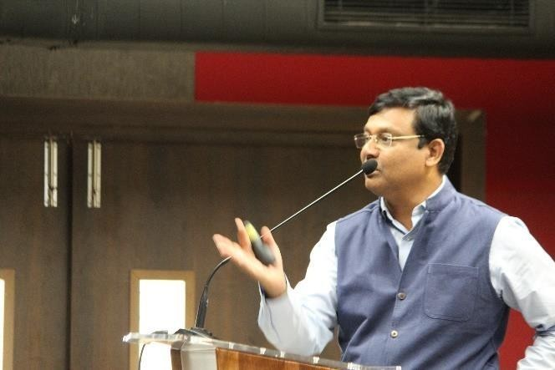
Anil Rachamalla sir is a Digital Well-being Expert, Founder of End Now Foundation and the prime speaker for the day. Anil sir had begun his first summary of the day with a very sensitive yet interesting topic ‘Online Consent’. Sir, started by explaining how Online consent is different from offline consent and why it is more crucial in comparison. Sir has given examples on how a simple consent approval can make big changes. He had explained on how giving away consent can be
problematic in the digital world. Anil sir also hosted a fun session called thematic painting with the theme ‘Digital well-being’. Students were asked to bring out the creative side to illustrate a drawing depicting the digital world and followed by there was picture interpretation on various animated pictures depicting the present and future digital era.

Session 3:
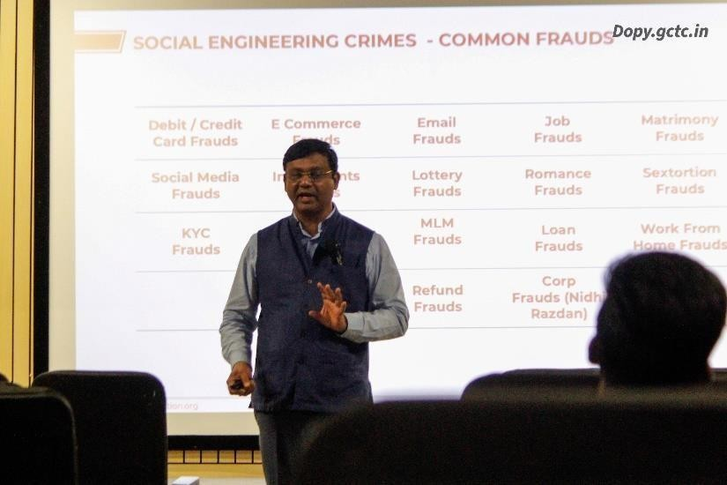
Anil Rachamalla sir came with the second session of the day on the concept of ‘Social Engineering’. Sir had given us a brief explanation on what is social engineering and different ways that is used. Each concept of social engineering was clearly explained through examples and real- time cases. Starting from password security to securing our private data, each concept was covered with interaction with the students. Students enjoyed the sessions and we received
most participation and interaction from them. Apart from the core concept Anil sir also interacted with students regarding some of the internet crimes that he witnessed and helped people getting out of it. He has covered about various honey trap cases and hacking cases like juice-jacking. Overall, students had the most productive day lead by Anil sir with his compelling seminars and engaging activities.

Summary:
The second day was then followed by wonderful reviews from students. Students who had doubts about the core concept and interested in the field had expressed their happiness of attending the congress. Students thanked Anil sir for the wonderful sessions and expressed their gratitude towards the club. Succeeding, that, there was a formal valedictory session conducted in which the club expressed it’s Vote of Thanks on behalf of all the students. The guest of the day Mr. Anil Rachamalla garu also gave away the prizes for the winners and runners in the competitions conducted under “Cyberlympics”.

WINNERS:
Cyberlympics is a series of competitions held under Cyber Congress 2022. The competitions were thematic under various concepts of Cyber Security.

Competition | Winner | Runner
Paper Presentation | Vempaty Bhanu Vamsi | -
Poster Presentation | S Sai Lahari | Thakur Amulya
Pictography | Akash Reddy Nallaralla | Vempaty Bhanu Vamsi

Captures of the event:

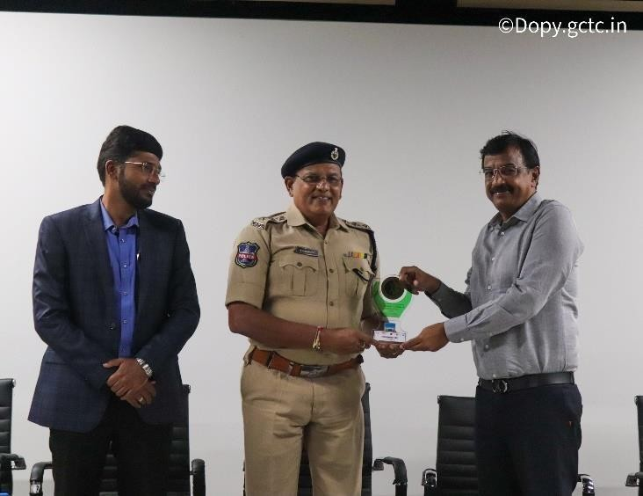
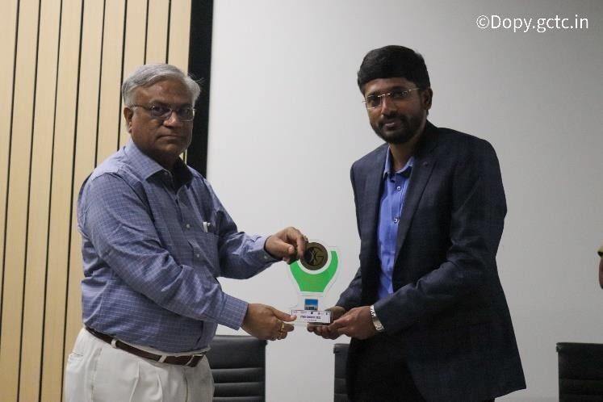

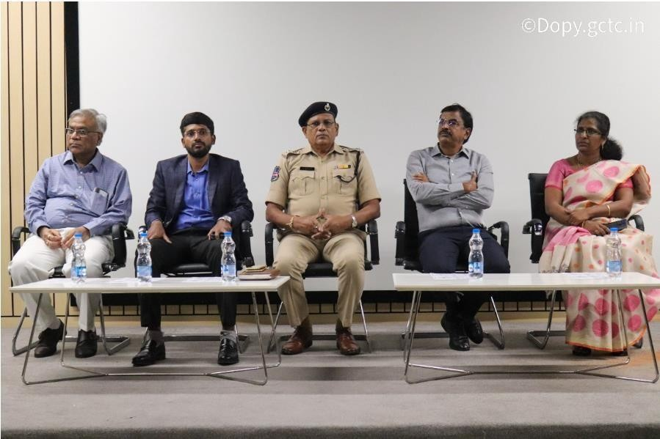

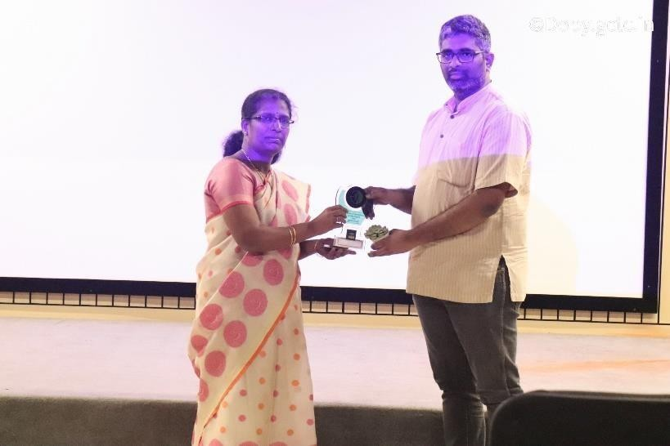
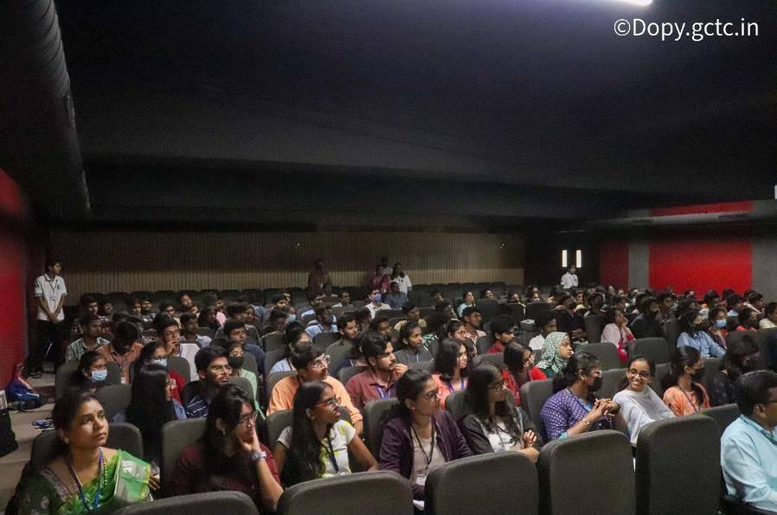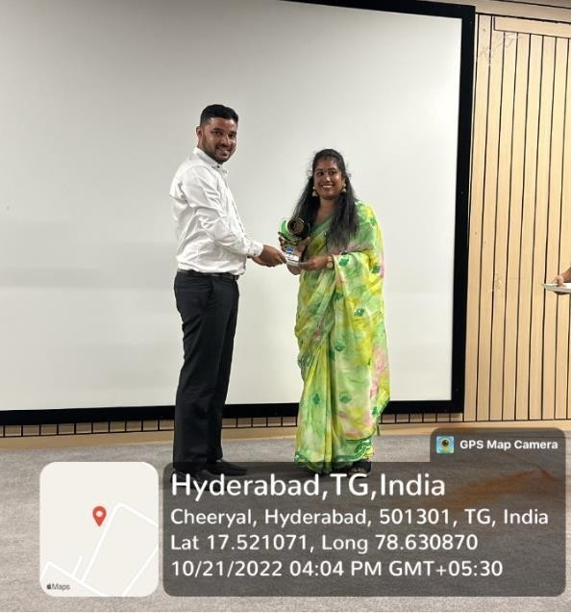

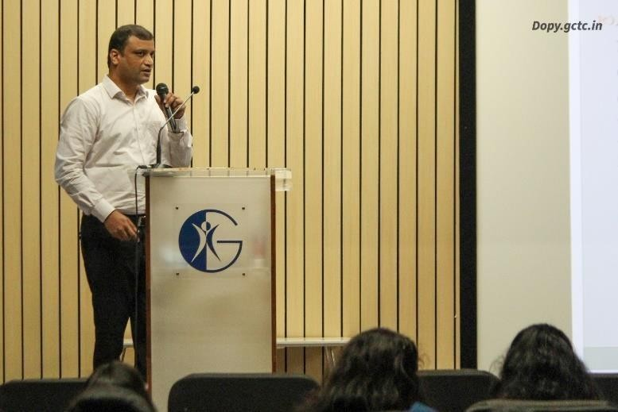
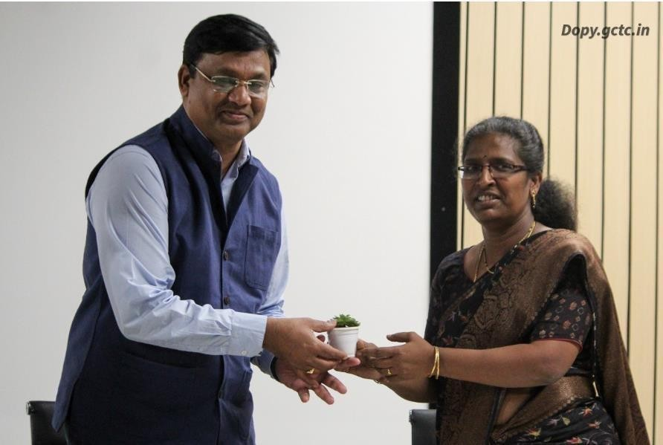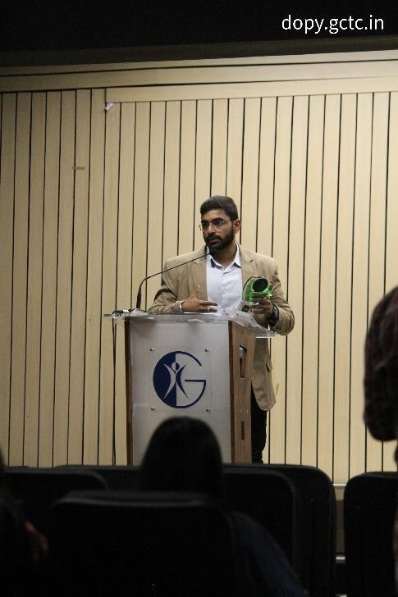

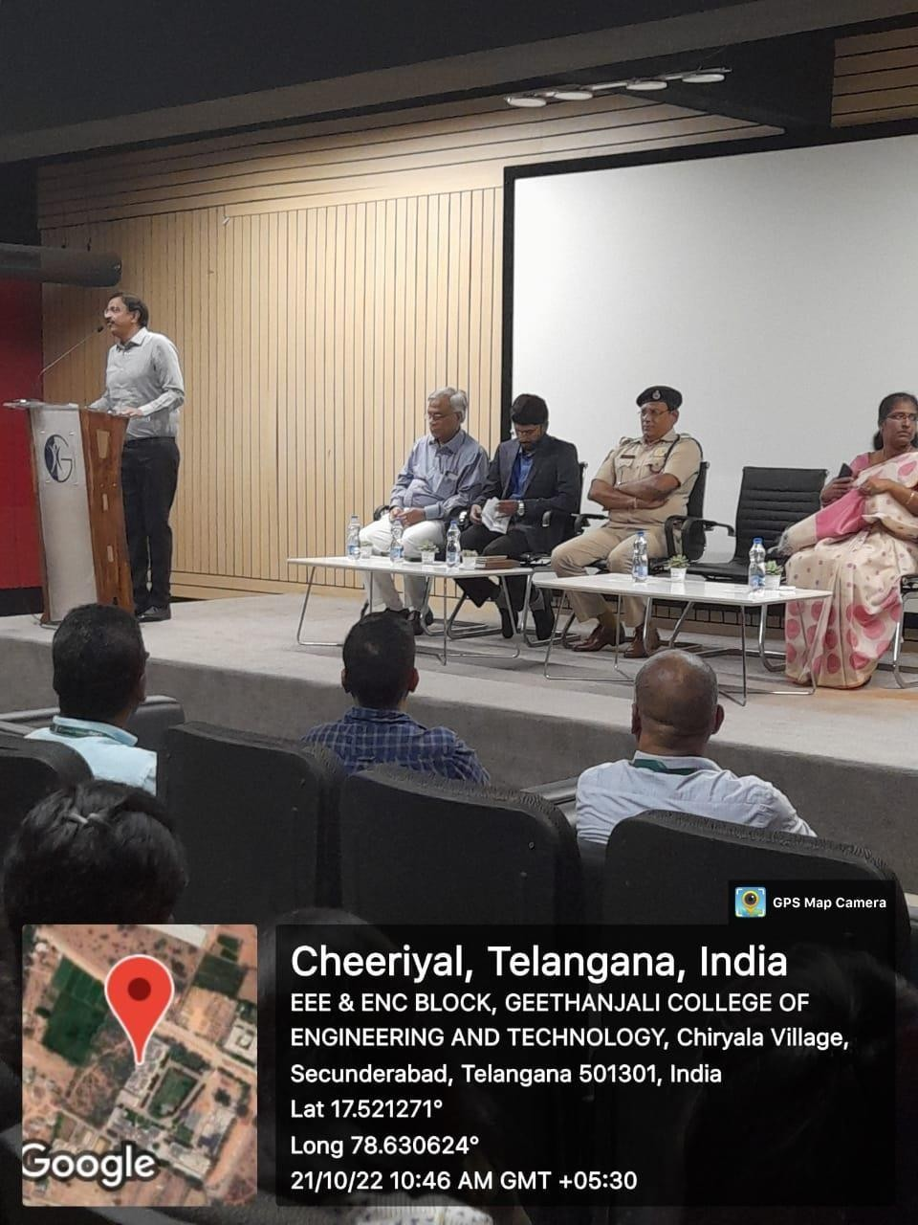
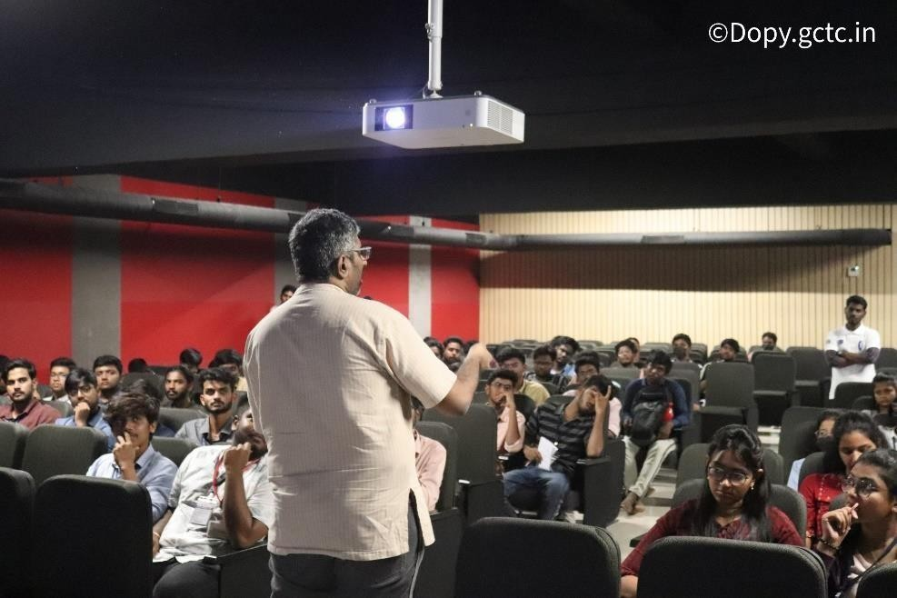

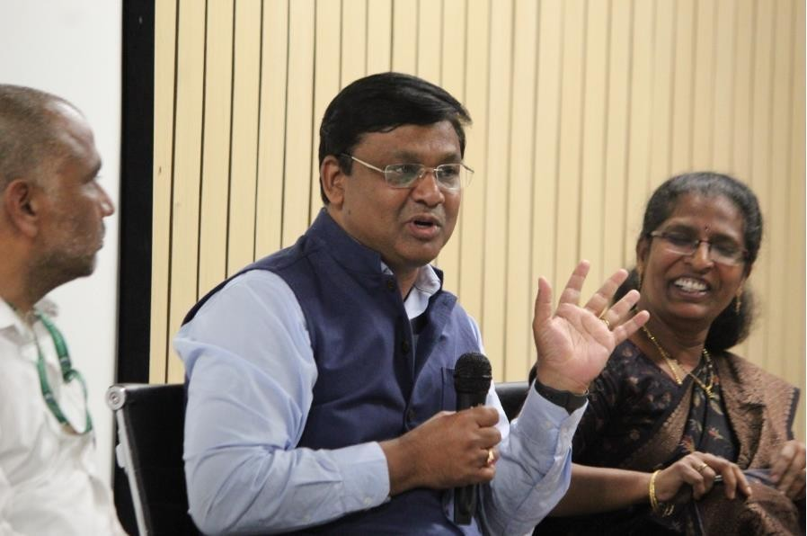

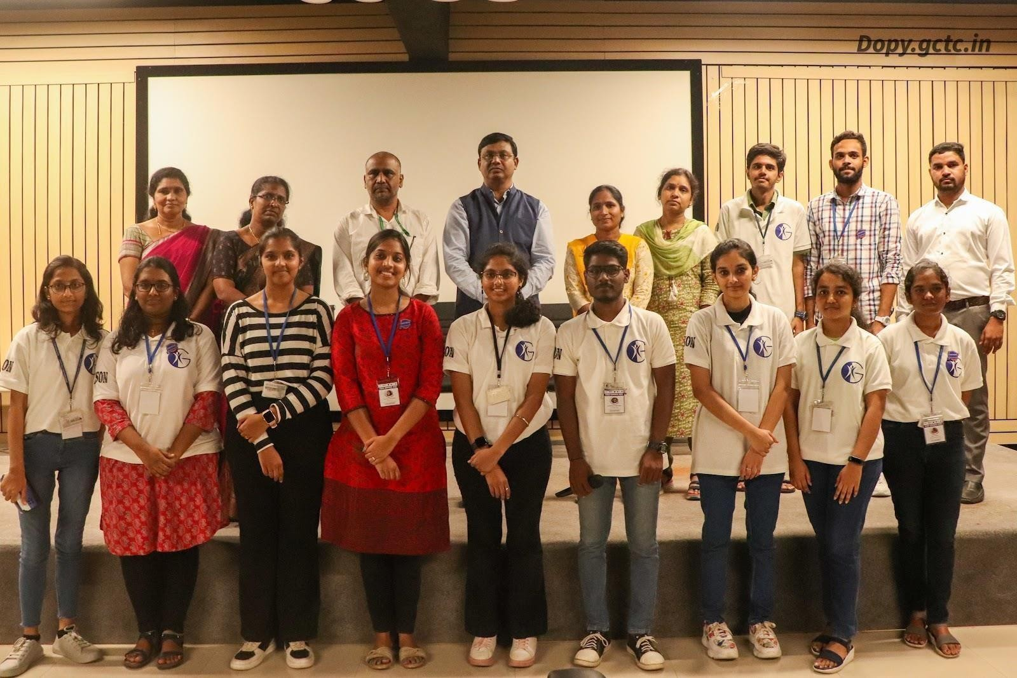

Thematic Paintings:
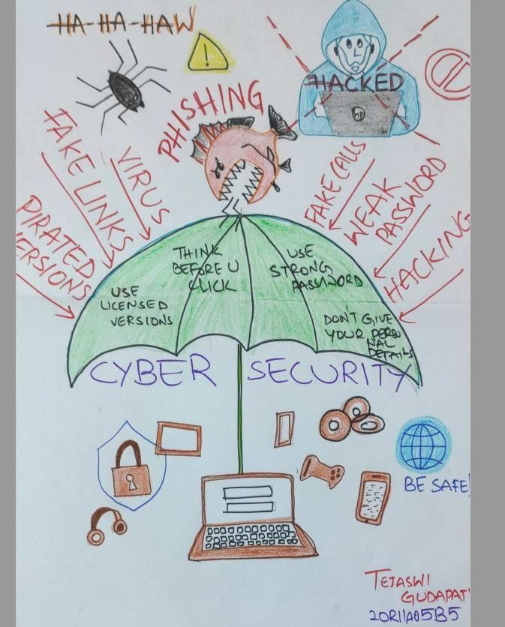
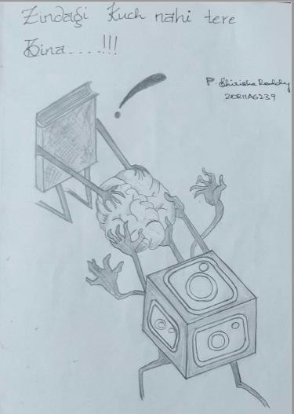

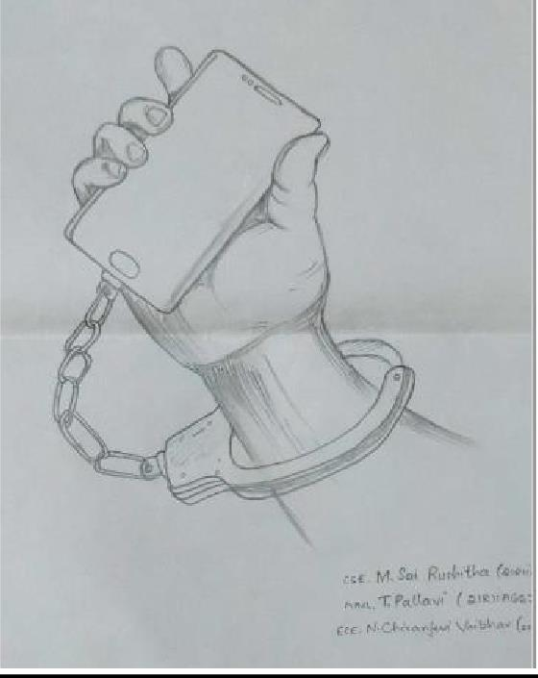

Statistics:
Below is the statistical response received from the delegates regarding the event.

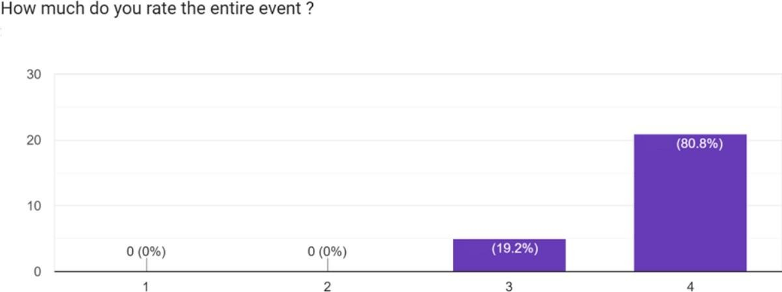

Feedback:
Cyber Congress 2022, has been the most engaging event of the year with such valuable seminars delivered by the dignitary speakers. The Congress incorporated both fun-filled and skilled events through-out the month, promoting the Cyber-Awareness month. Students had a great experience meeting the field experts and getting insights from them. Students were also part of Cyberlympics and participated in the competitions. Cyber Congress has motivated lot of students in building their career in field of Cyber Security by getting clarity from the speakers.

(3-Day Bootcamp) + Hackathon on Ethical Hacking and Cyber Security Fundamentals
Report

EVENT DETAILS:
- Dates
Bootcamp : 23rd March 2023 to 25th March 2023
Hackathon : 25th March 2023 5PM to 26th March 2023 12PM

- Venue : Geethanjali College of Engineering and technology.

- Number of participants : 71

FACULTY CORDINATORS:
- Mrs. B Mamatha

STUDENT CORDINATORS:
- Sai Prakash Chary Vadla
- Veena Vani Pedduri
- T SreeAlekhya
- DharavathRounith
- Duvvuri Sree Sai Soujanya
- KosgiAakanksha Reddy
- Hari Sarada
- Tanvi Shivani
- K Rohitha
- Maramamula Sai Sri Vishnu

About the event:
A 3-day bootcamp on Ethical Hacking and CyberSecurity fundamentals followed by a Hackathonwas organized by the Cyber Security Club of GCET and Department of Computer Science in association with Supraja technologies in Geethanjali College of Engineering and Technology during the mentioned time period.

Objective
The primary objective of the event was to educate participants on the fundamentals of cyber security and ethical hacking, with the aim of increasing their knowledge and understanding of the importance of securing digital assets and protecting against cyber threats. Through the bootcamp, participants were introduced to various cyber security concepts and practices, such as data encryption, network security, and ethical hacking techniques. By the end of the event, participants were able to have a strong grasp of the fundamentals of cyber security and ethical hacking, and were better equipped to safeguard their digital assets and mitigate cyber risks.The event was also aimed at encouraging participants to pursue careers in cyber security and related fields by showcasing the diversity of opportunities available and the importance of this field in the digital age
- Students who performed well in the hackathon received an internship offer from Supraja Technologies. The experience they will gather during the internship will help them in making a good career in Cyber Security.

About the company:
Supraja technologies is a company solely based on cyber security and it has been successful in giving internships to many students who are currently successfully flourishing in their career. They believe in team commitment and always value creators.
Description
Day – 1
On the first day of the bootcamp, the participants were welcomed and introduced to the program.
The instructors then moved on to discussing the basics of cyber security, including the different types of hackers, such as black hat, white hat, and grey hat hackers. The participants were given an overview of the motives and characteristics of each type of hacker, as well as the tools and techniques they use to exploit vulnerabilities in networks and software. Some common technical terms used in the domain were explained to the participants.
Next, the instructors introduced the participants to small vulnerabilities that are commonly found in networks and software. The session covered topics such as weak passwords, unsecured Wi-Fi networks, location-disclosing applications and phishing attacks. The participants were taught how to identify and protect against these vulnerabilities, and how to respond in case of an attack.Instructors elaborated the concept of Cyber laws and how these laws are designed to protect individuals and organizations from cyber-crimes, such as hacking, identity theft, and cyberbullying.
The session also included hands-on exercises, where the participants were given the opportunity to practice identifying and exploiting vulnerabilities in some known environments. Some vulnerabilities were disclosed to students, which helped them understand the importance of implementing security measures in real-world situations.
Overall, the first day of the bootcamp provided an engaging and interactive introduction to the world of cyber security, laying the foundation for the more advanced concepts that would be covered in the following days. The participants were left with a better understanding of the basics of cyber security.
Day 2
On the second day of the bootcamp, participants delved deeper into the world of cyber security, starting with a discussion on cookies. The instructors explained how cookies work, their importance in online transactions, and the risks associated with storing sensitive information in cookies. Participants learned how to manage and delete cookies to protect their online privacy and security.
The instructors also introduced participants to the phases of ethical hacking, including reconnaissance, scanning, gaining access, maintaining access, and covering tracks. Participants learned how these phases work together to help identify and exploit vulnerabilities in systems, as well as how to defend against attacks by understanding these phases.
Next, the participants were reminded of the importance of being cautious about logging in to every website they come across. The instructors emphasized the importance of verifying the authenticity of websites before sharing sensitive information and provided practical tips for safe browsing via temp emails.
The session then moved on to safer mailing options, where the participants were introduced to encrypted email services and how they can be used to protect sensitive information. Finally, the instructors covered virus identification, discussing how to identify common signs of a virus.
Overall, the second day of the bootcamp provided participants with a deeper understanding of cyber security concepts and practical skills to protect against cyber threats. Participants left the session with the knowledge and confidence to navigate the online world more safely and securely.
Day 3
On the third day of the bootcamp, the focus shifted to practical tools and techniques for monitoring and protecting networks. The participants were introduced to software tools that could be used to monitor network traffic and capture packets. They learned how to use these tools to identify user activities and find suspicious behavior on their network.
The session started with an overview of network monitoring and the different types of network traffic that can be captured, such as HTTP, FTP, and SMTP. The instructors explained how to use packet capture tools to analyze network traffic and identify patterns that may indicate suspicious behavior.The session also included hands-on exercises, where participants had the opportunity to use these tools to analyze real-world network traffic and user activity data.
Participants were given tasks where they were provided with captured packets of some networks and were asked to find details of users, their login activities, shared files and user activity.The speaker discussed various response codes and provided detailed information on the use of IP addresses. However, the primary focus of the day was on the topic of "sniffing". Participants received a comprehensive explanation of what sniffing is and how to identify the flags associated with it. The speaker demonstrated how to proceed at different levels during sniffing.
The speaker introduced the concept of "steganography". Participants were challenged to find hidden messages in images and voice notes using various steganographic tools. They explored different tools by browsing and attempting to identify morse codes hidden in voice notes, making it another exciting aspect of the day. Participants were able to discover some tools and uncover hidden messages using them.
At the end of day 3, an assessment was conducted before the hackathon to assess participants and the knowledge gathered by them during the 3-day bootcamp.

Hackathon
The hackathon began on 25th March at 5PM and continued until 26th March 12PM. The goal of the hackathon was to challenge the participants and assess the skills acquired by them during the bootcamp.The cyber security hackathon was a challenging event that put participants' skills to the test in a variety of security aspects. The event featured multiple challenges, including steganography, capture the flag, packet tracing, and more. In the steganography challenge, participants had to uncover hidden messages within images or other media. The capture the flag challenge required participants to find and exploit vulnerabilities in a simulated system. Packet tracing involved analyzing network traffic to identify potential threats or suspicious activity. Throughout the hackathon, participants were also exposed to other security-related tasks and puzzles that required a deep understanding of cyber security principles and tools. Overall, the hackathon provided an excellent opportunity for participants to showcase their skills, learn new techniques, and collaborate with like-minded individuals.

50 out of 71 participants were provided with internship offers at the end of the hackathon.

Pictures
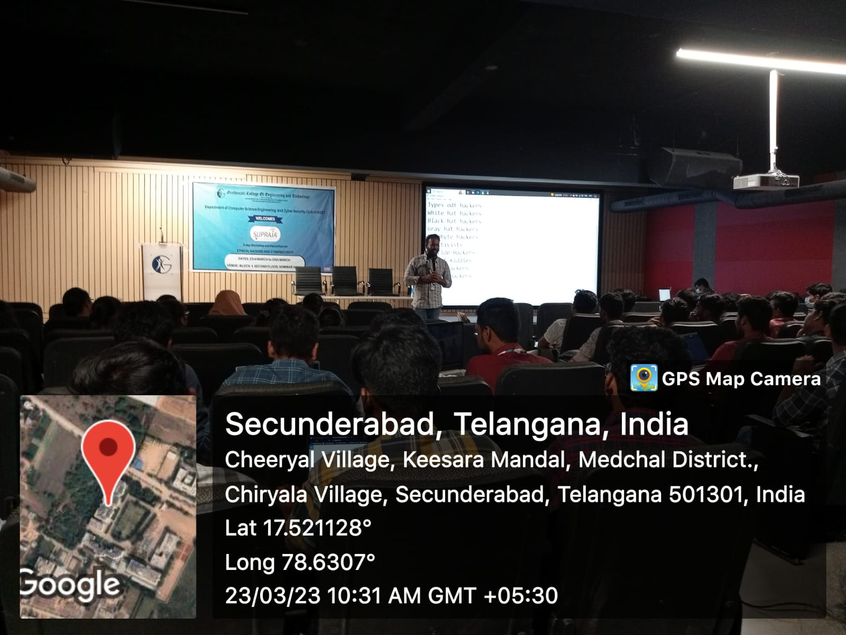
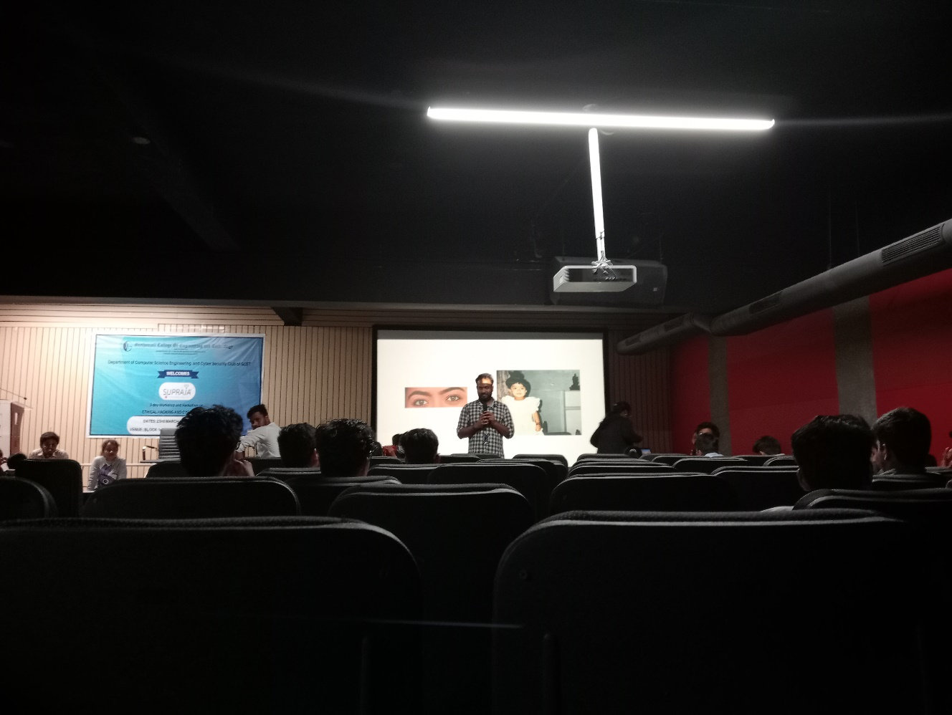

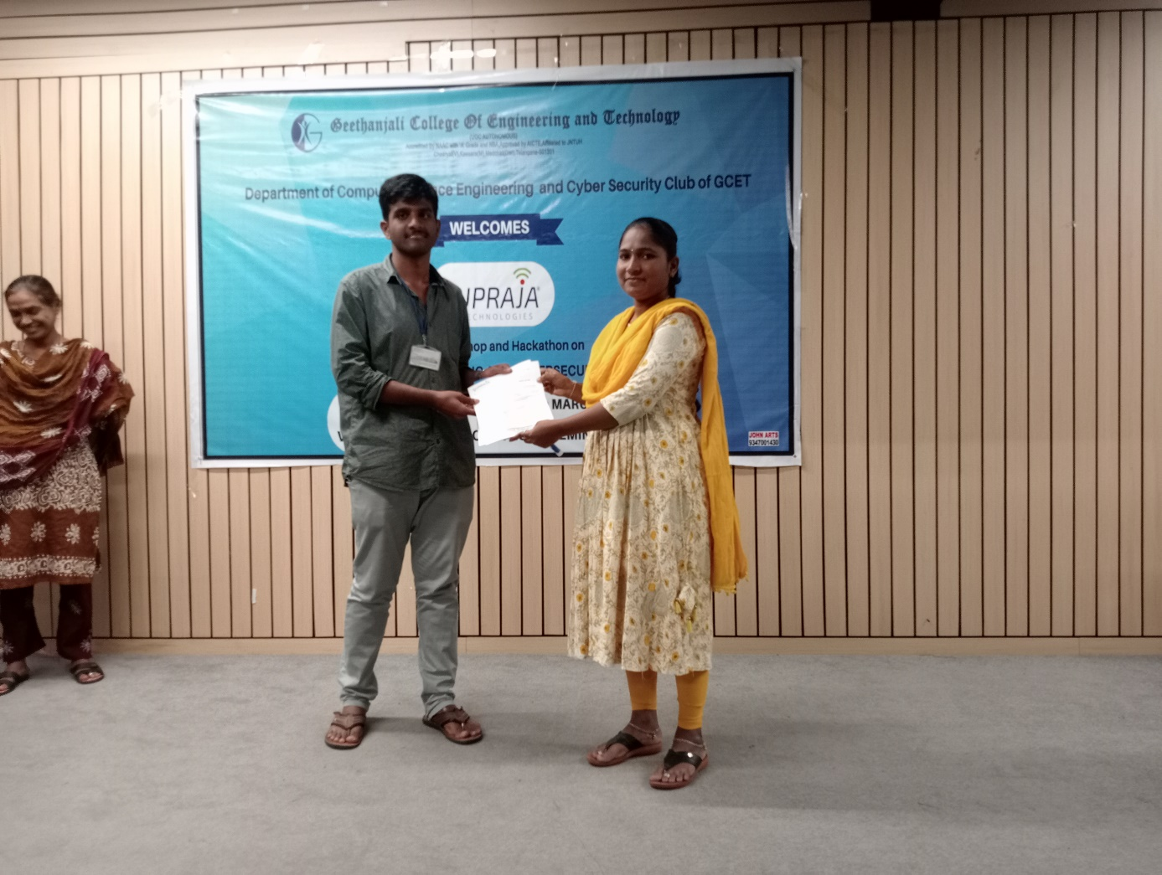
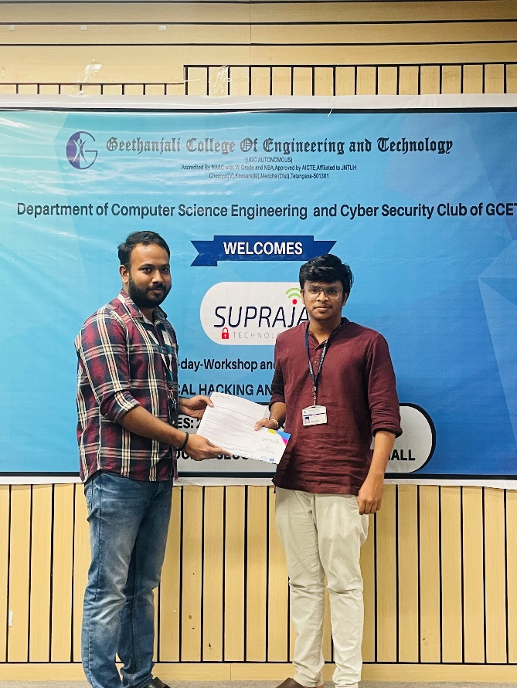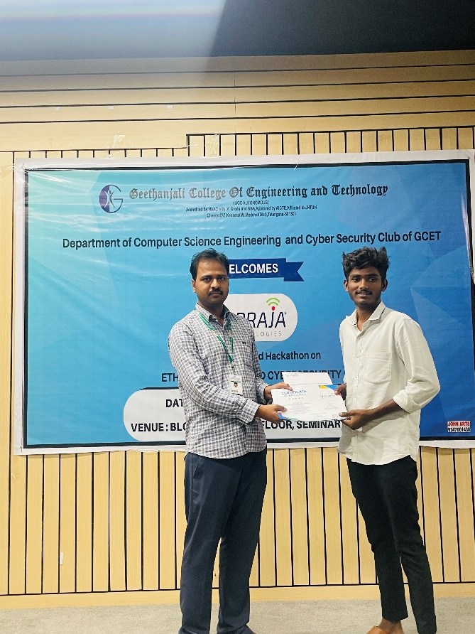

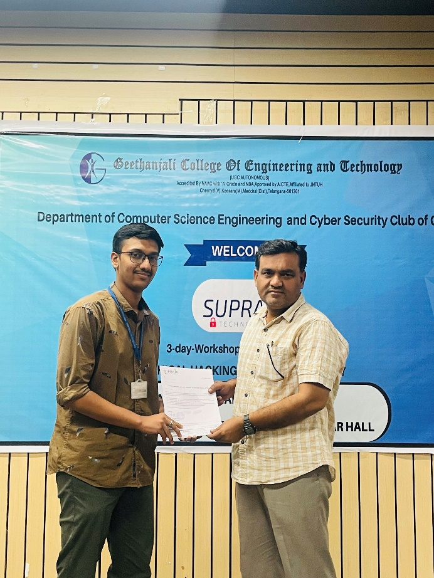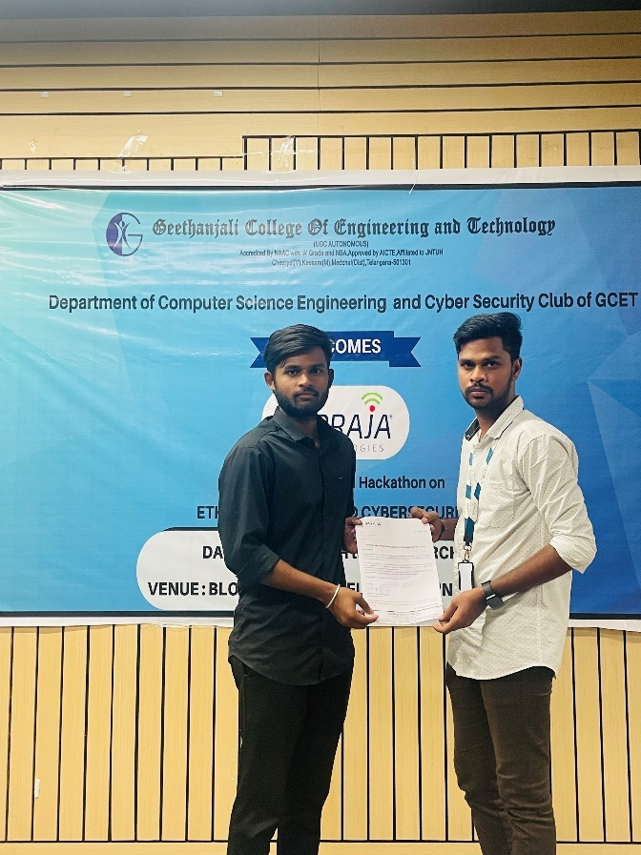

List of students who attended the bootcamp+Hackathon
Total: 71 participants
Roll Number | Name
21R11A6235 | MADIHA FATHIMA
21R11A0567 | Erramuri Dhanush RajKumar
21r11a05r4 | Varsha N
21R11A6258 | Thakur Tejaeshwar Singh
21r11a6264 | Yatahruthvikreddy
21R11A6263 | YAMA SHIVA PRASAD
21r11a04c9 | Komuravellyashish
21R11A0597 | Shivanoor Vignesh
21R11A6244 | Nunnavamsi
21R11A0589 | R Naveen
21R12A0572 | HanumandlaYeshwanth Reddy
21R11A6697 | Aditya Panda
21R11A66D4 | Sai Keerthana Sandhiri
21R11A66D2 | Rutuja Venkat Bhadke
21R11A0593 | Pathuri Sai Vardhan Reddy
21R11A0582 | Hemanth Reddy
21R11A0579 | KarnatiMysanthosh
21R11A66E2 | VakkalagaddaSahith
21R11A6902 | Abdul razzak
21R11A6216 | D.Gowtham
21R11A6201 | AMMANABOLU ROHITH KUMAR
21R11A1258 | TANGELLA SIDDHARTHA
22R15A1205 | K. PRASHANTH
21R11A6236 | M Likith
22R15A1202 | BodasuYashwanth
21R11A0415 | RAGHAVENDRA REDDY JAKKIDI
21R11A0447 | V.V.B. KRUPA VAIBHAV
21r11a05n9 | Mahidhar
21R11A6249 | Sai kiran
21R11A1252 | Shaik Ayan
21R11A1253 | SHAIK TAUSIF
21R11A6655 | A. V. K Karthik
21R11A6687 | Salveru Keerthana
21R11A1220 | Israa Javeed
21R11A6683 | PagaManasa Reddy
21R11A6237 | Mohammed.Afshaan Uddin
21r11a1239 | Mashettisuhas
21R11A05N2 | KalwaSumith Reddy
21R11A05R3 | U Vijay Vardhan
21R11A6254 | S.Nithesh
21R11A6256 | TADAKALA SAI KUMAR
21R11A6684 | Palle.Yaksha Reddy
22R15AO501 | ChakailNandeeshwar
21r11a6658 | Chitturi Deepak
21R11A05N4 | KasulaYashwanth
21R11A05N1 | K. Nanda Kishore Reddi
21R11A6227 | K Madhavan
21R11A05A5 | A BHAVYA SRI
21R11A6220 | G Manideep Reddy
22R15A6202 | A.Hemanth
22R15A6206 | Shaik Ayazul Hasan
22R15A6207 | Shaik Khamruddin
22R15A6608 | A.Dharani Goud
21R11A6232 | K.kedarnath
21R11A6247 | Parvathi Uday Param
20R11A05N1 | DeekshithaPagadala
21R11A6666 | Guttameedi Chakrika
21R11A6728 | Lingala Srinivas Prabhas
21R11A05M1 | Bandari Arjun
21R11A05R2 | Tholapi Sri kartik
21r11a6965 | Yellankiajay
21r11a6942 | Avinash
21R11A6941 | Ram Charan
21r116925 | Abhinav
21r116923 | G Bharat
21r116919 | D Shashank
21r11a6675 | Harika
21r11a6678 | Sai Kiran
21r11a6681 | Ganesh
21r11a6692 | Dharma Nithin T
21r11a6686 | R lahari

Students who received internship offers
SNO | ROLL NUMBER | NAME | MOBILE | BRANCH | YEAR
1 | 20R11A05N1 | Deekshitha Pagadala | 8106751895 | CSE | III
2 | 21R11A0567 | Erramuri Dhanush Rajkumar | 8019618201 | CSE | II
3 | 21R11A0579 | Karnati Mysanthosh | 6281084437 | CSE | II
4 | 21R11A0582 | Hemanth Reddy | 9347494190 | CSE | II
5 | 21R11A0589 | R Naveen | 6281125339 | CSE | II
6 | 21R11A05A5 | A Bhavya Sri | 9515351352 | CSE | II
7 | 21R11A05M1 | Bandari Arjun | 9618516706 | CSE | II
8 | 21R11A05M1 | Bandari Arjun | 9618516706 | CSE | II
9 | 21R11A05N1 | K. Nanda Kishore Reddi | 9290572494 | CSE | II
10 | 21R11A05N2 | Kalwa Sumith Reddy | 9550835468 | CSE | II
11 | 21R11A05N9 | Mahidhar | 9908981399 | CSE | II
12 | 21R11A05R2 | Sri Karthik |  | CSE | II
13 | 21R11A05R3 | U Vijay Vardhan | 6281518298 | CSE | II
14 | 22R15AO501 | Chakail Nandeeshwar | 9100147369 | CSE | II
15 | 21R11A0593 | Pathuri Sai Vardhan Reddy | 9494260026 | CSE | II
16 | 21R11A6675 | Harika |  | AIML | II
17 | 21R11A6678 | Sai Kiran |  | AIML | II
18 | 21R11A6686 | R. Lahari |  | AIML | II
19 | 21R11A6692 | T. Dharma Nitin |  | AIML | II
20 | 21R11A6697 | Aditya Panda | 9963472014 | AIML | II
21 | 21R11A66E2 | Vakkalagadda Sahith | 8309459335 | AIML | II
22 | 21R11A66D4 | Sai Keerthana Sandhiri | 7386503444 | AIML | II
23 | 21R11A6655 | A. V. K Karthik | 9701287347 | AIML | II
24 | 21R11A6683 | Paga Manasa Reddy | 9553666651 | AIML | II
25 | 21R11A6687 | Salveru Keerthana | 9959333803 | AIML | II
26 | 21R11A66D2 | Rutuja Venkat Bhadke | 8247380105 | AIML | II
27 | 21R11A6666 | Guttameedi Chakrika | 9182225733 | AIML | II
28 | 21R11A6658 | Chitturi Deepak | 8686987799 | AIML | II
29 | 21R11A6684 | Palle.Yaksha Reddy | 6305882239 | AIML | II
30 | 21R11A6216 | D.Gowtham | 6305110259 | CS | II
31 | 21R11A6235 | Madiha Fathima | 6309489446 | CS | II
32 | 21R11A6220 | G Manideep Reddy | 8555004290 | CS | II
33 | 21R11A6258 | Thakur Tejaeshwar Singh | 9391722640 | CS | II
34 | 21R11A6227 | K Madhavan | 9347661337 | CS | II
35 | 21R11A6247 | Parvathi Uday Param | 9866303828 | CS | II
36 | 21R11A6249 | Sai Kiran | 6303591142 | CS | II
37 | 21R11A6256 | Tadakala Sai Kumar | 9666132218 | CS | II
38 | 21R11A6263 | Yama Shiva Prasad | 9010903686 | CS | II
39 | 21R11A6236 | M Likith | 9347634446 | CS | II
40 | 22R15A6202 | A.Hemanth | 8466950889 | CS | II
41 | 22R15A6206 | Shaik Ayazul Hasan | 7013731463 | CS | II
42 | 21R11A6728 | Lingala Srinivas Prabhas | 9381756829 | DS | II
43 | 21R11AO239 | Mashetti Suhas | 6302293716 | IT | II
44 | 22R15A1202 | Bodasu Yashwanth | 6305503050 | IT | II
45 | 22R15A1205 | K. Prashanth | 8074801486 | IT | II
46 | 21R11A6923 | G. Bharath |  | IOT | II
47 | 21R11A6925 | Abhinav |  | IOT | II
48 | 21R11A6941 | Ram Charan |  | IOT | II
49 | 21R11A6942 | Avinash |  | IOT | II
50 | 21R11A04C9 | Komuravelly Ashish | 8121072701 | ECE | II

Feedback
- I'm very happy that I was part of this boot camp.I have learnt many things about the backend security system and the decoding process.The trainers and coordinators were very joyful and helped us to complete the tasks very easily and this was the best one which I have experienced

- It was very good and informational

- Firstly id' honestly like to thank the members of the cybersecurity club members prior to the supraja technologies team because if it weren’t the cybersecurity team then we wouldn't have got this opportunity to attend the bootcamp and hackathon and it met my expectations and kudos to all the club. Thank you for giving me this opportunity.

- We had a very good learning experience. The club members were so helping and the trainers were also very supportive.

- It was an amazing experience

- It’s was thrill exciting and a challenging and acknowledging session I totally loved it

- It was the best event I attended in college

- This was an Excellent event. I have enjoyed a lot thank you so much guys i am very glad to meet you all and thankyou guys so that i learnt something new and presented it through exam and got selected for internship.

